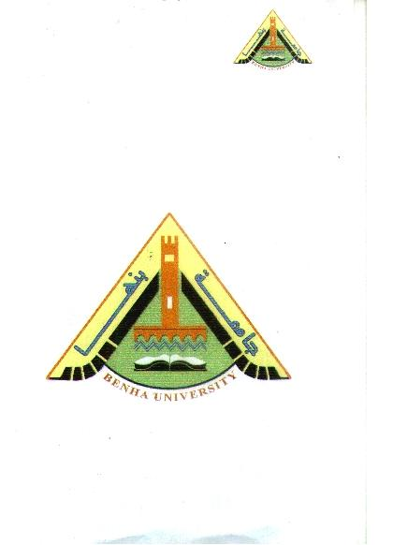
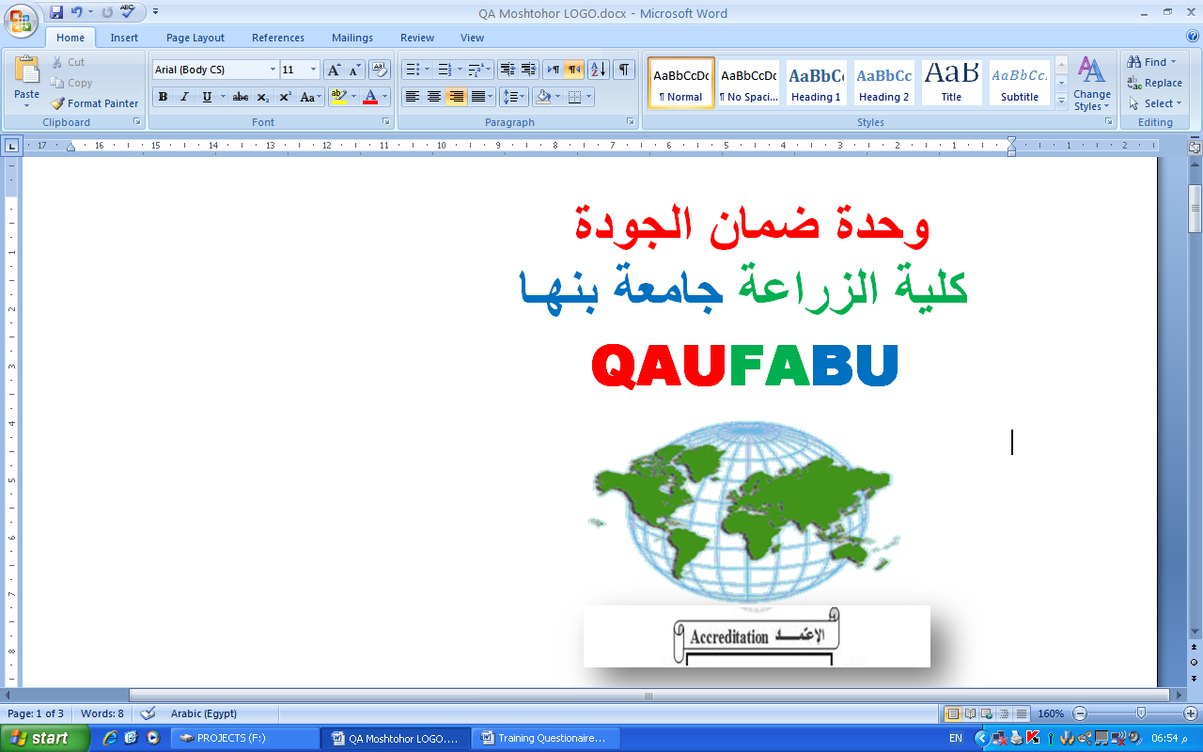
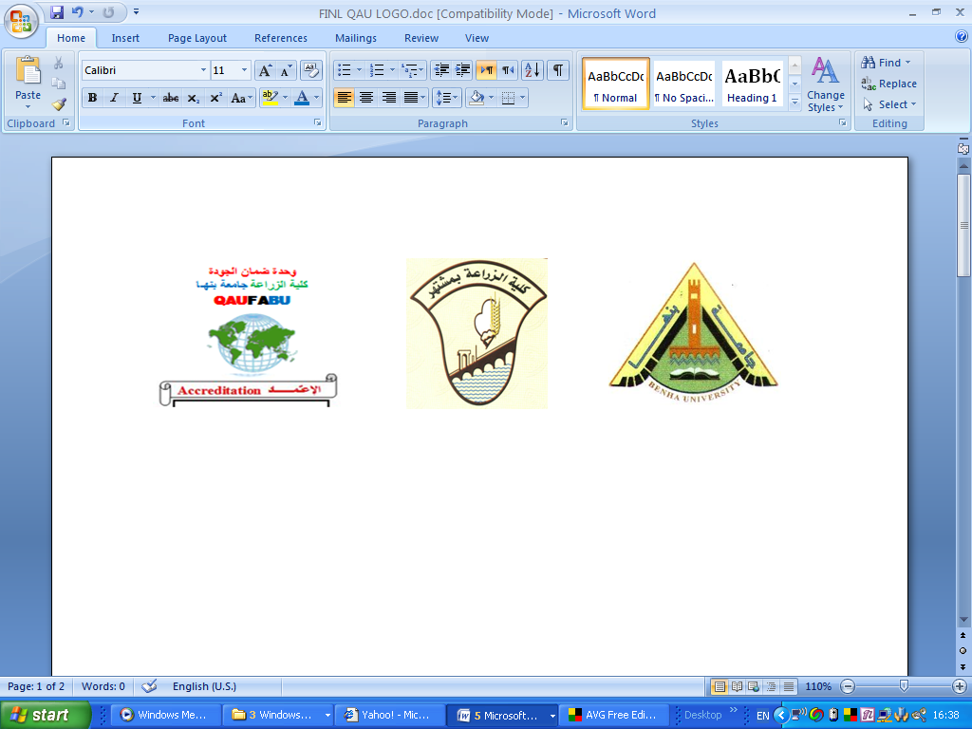

Benha University Model Answer 1st Semester
Faculty of Agriculture Entomology (general)
Plant Protection Dept. Level II – Food Safety 2016/2017

Answer of First Question: (Student has to answer only three from 4 questions).
- Female reproductive system Male reproductive system
- A pair of ovaries - A pair of testes; each containing
- Ovaries imply their mature oocytes into a series of testicular tubes, in each,
a lateral oviduct. The two lateral oviducts the spermatozoa are produced.
unite to form a median oviduct. This oviduct - Sperms move to be stored in seminal
is concealed with body wall to form a genital vesicle through the two vas differens
chamber called vagina. There are two types which lead to the ejaculatory duct.There
of glands; Spermatheca and accessory glands. are from 1 to 3 pairs of accessory glands.
Drawings are as shown in the lectures’ written note.

- a- The functions of insect heart are to help in the following:
- transportation of nutrients.
- Movement of limbs, mouthparts, ------------- etc.
- Moulting; by increasing pressure in certain parts of body.
- Resistance and immunity.
- Helps in thermoregulation.
b- Drawing of the digestive system is as shown in the lectures’ note.

- a- The types of insect larvae:
- Protopod larvae - Oligopod larvae - Polypod larvae - Apodous larvae
Drawings are as shown in the lectures’ note.
b- Charactertistics on which insect classification depends:
- Presence or absence of wings.
- Number of wings and its types.
- Number of insect segments.
- The form of connection between the three main zones of insect (Head,
Thorax and Abdomen).
- The types of metamorphosis.
- The types of mouthparts.
- Life-cycle
- Presence or absence of compound eyes and ocelli.
- Presence or absence of malpighian tubes.
- Tracheae and tracheoles.
- Types of legs and number of tarsal segments. and many others
4- a-
- Sex-ratio: is the ratio of females to males in generation.
- Fecundity: is the total number of eggs laid/female.
- species: a group of insects which has similar characteristics (morphological,
ecological and physiological), and these individuals have the ability for
copulation and producing fertile progeny.
- Nutritive potentiality: is the ability of insect to use the food occurring in the
environment and transform it to the best form.

b- Comparison between insect egg and sperm: as shown in the drawings in the
lectures’ written notes.

Answer of the Second Question: (Student has to answer three questions only):
- a-The required drawing of an insect is as shown in the lectures’ note. The parts needed to be shown are; The Head, Thorax and the Abdomen. About the head, you have to show the antennae and the compound eyes; on the thorax to show the legs and the wings; and on the abdomen you have to show the genitalia and the anal-cerci.
- The general characteristics of Class Insecta:
- Body divided to head, thorax and abdomen.
- The head carries two compound eyes, pair of antennae and mouth-parts.
- The thorax carries three pairs of legs and two pairs of wings.
- The abdomen has no appendages except the genitalia and the anal-cerci.
- Insects respirate through pairs of spiracles which open to outside.
- Anal-cerci, if present, are one pair seen at the end of the abdomen.
- Insects get rid of the uric acid through malpighian tubules.
- Insects are egg-layers; eggs develop until reaching the adult stage through metamorphosis.

- a- The factors which suppress insects’ populations are:
Abiotic factors:
- Temperature: the optimum temperature for best survival of the insect. As termperature moves up or down, the viability of insect decreases until reaching the dormant temperature. More increase or decrease until reaching the fatal temperature at which the insect dies.
- Relative humidity: At the optimum R.H., the insect shows best survival. As R.H. increases or decreases, it will reach the dormant R.H., then by more increase or decrease, it will reach the fatal R.H. causing insect mortality.
- Climate: includes temperature, rainfall, air movement, light and radiation; those comprise a complex of factors which play together a role which determine the insect’s activity.
Biotic factors: Include predators, parasitoids and pathogens (bacteria, fungi and virus) which play a very important natural role in suppressing the populations of insects.

b- Steps of moulting of a larva to reach the next instar:
- larva stop feeding and become quiescent.
- the hypodermal cells become active and start secretion of the moulting fluid which contains chitinase and protease that dissolve the endocuticle of the old skin which becomes separated from the hypodermis layer.
- the hypodermal cells start to secrete the epicuticle of the new integument followed by exocuticle then endocuticle.
- the remaining moulting fluid is absorbed through the body surface.
- the larva starts contraction of its abdomen and presses by its thorax, so the ecdysal suture ruptures and the new larval instar wriggles out and gets rid of the old skin.

- a- Drawing of mandible of the aphid lion larva is present in the lectures’ note.
You have to clarify in your drawing that it is wide at the bottom and
sharply attenuated at its tip. You have to draw also the longitudinal groove
through which the larva sucks all fluids in the pray causing its death.

b-Tarsus of the hind leg of the honeybee worker is clarified in the lectures’ ,
note. You have to show that the first tarsal segment is transferred to a pollen grains basket as it is much bigger than the remaining segmets and it is provided with 10 rows of hairs on which the pollen grains of flowers are carried until the bee worker returns back to its hive.

- a- The mantid foreleg is drawn in your lectures note. You have to clarify on
your drawing that it is composed from the coxa, trochanter, long femur,
long tibia and the 5-segmented tarsus. You have to show in your drawing
the longitudinal groove (with strong spines on both sides) in the femur and
the long tibia with spines.

b- Drawings of the three types of wing coupling apparatus are clearly shown in
your lectures’ written note; those are the frenate, hamulate and jugate types.
You have to draw only one of the three types.For example, if you choose
to draw the frenate type, you have to show the frenulum at the basal part of
the hind wing and how is it attached to the long hairs (in female) or to the
curved hook (in male) which lie on the underside of the forewing.

_____________________________________________________________

Prof. Dr. Ezzat Farag Elkhayat Prof. Dr. Fawzy Faiek Shalaby

