
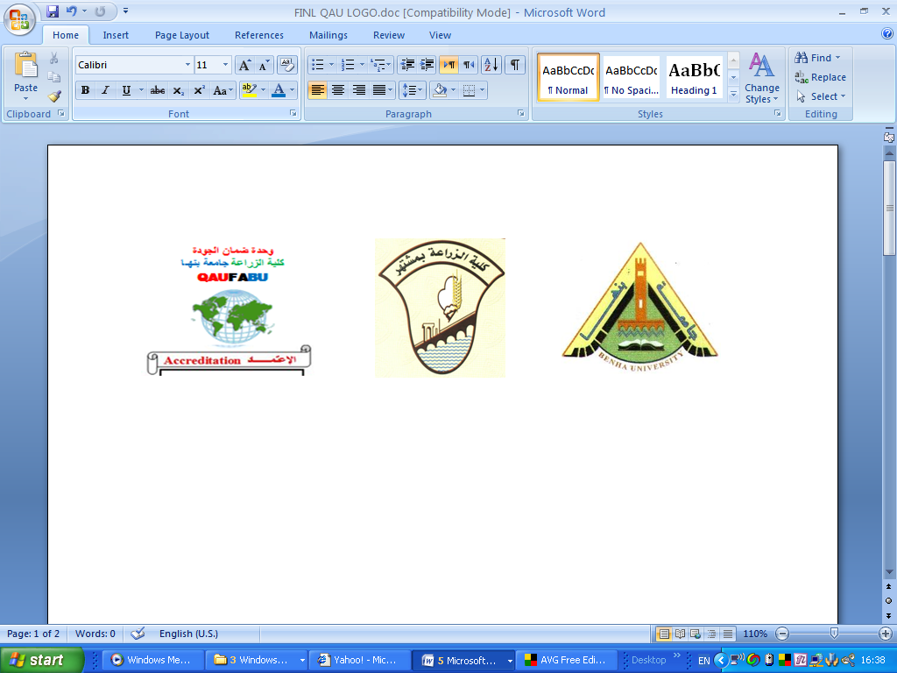

Agronomy Department First Year Term I
Computer Science Model answer of Final exam 2017
New English Programs Time allowed: 2 hours

Answer of the First Question: (15 Marks)
- Mention five uses of a computer in agriculture.
- Controlling banking transactions and customer accounts in different banks with a great deal of speed and security. The customers can draw money through ATM card (Automated Teller Machine) from any branch of the bank at any time of a day.
- Editing all kinds of documents through using Word Processing Programs like Microsoft Office.
- Analyzing different data using statistical packages such as SAS, SPSS, MSTATC, etc…
- Collecting review for the sake of scientific research in different specializations.
- Establishing database for storing a huge quantities of data in different organizations using some programs such as ACCESS. dBASE, etc…
- How to keep your computer running smoothly and safety (Mention at least five points).
- Do a monthly clean up.
- Create system restore points regularly.
- Create backup disks.
- Use anti-spyware software
- Delete cookies. …etc…..

- What is the difference between: Intranet, extranet.
Extranet:
It is an internal network for one organization and aloows to every employee to use it through User name and Password.
Intranet:
It connects several organizations. Every one inside these organizations can use Intranet through User name and Password.

Second Question: (15 Marks)
- What is the importance of operating system in your computer?
The operating system is always present when a computer is running. It coordinates the operation of the other hardware and software components of the computer system. The operating system is responsible for starting up application programs, running them, and managing the resources that they need. When an application program is running, the operating system manages the details of the hardware for it. For example, when you type characters on the keyboard, the operating system determines which application program they are intended for and does the work of getting them there.
- How to open an application program (mention five methods).
- Right click on the program icon.
- Left click and inter from keyboard.
- Click the icon on task bar.
- Click Recent.
- Start, programs, office, word.
- What are the functions of the following commands:
RUN = executing of several commands for different tasks.
msinfo32 = properties of the computer apparatus.
Recent = several files opened in the last period of time.
Third Question: (15 Marks
Mark (√) in front of the true statement and (X) in front of the false one:
1- Border can be applied around a selected paragraph. √
2- Saving a word document as Rich Text Format means that some advanced formatting will be lost in the file conversion process. √
3- A paragraph will be selected when double clicking on any word within it. X
4- In PowerPoint presentation slide sorter view is used to easily rearrange slides. √
5- By clicking the lower part of New Slide button a new slide inserted instantly. X
6- Text can be copied from opened presentation then pasted to a closed one. X
7- A PowerPoint presentation can be saved as pdf file. √

Fourth Question: (15 Marks)
1- When saving a document for the first time, by default word save it into a folder called ( documents – downloads – recent ).
2-Creating a new word document can be done by pressing (ctrl+N - ctrl+F - ctrl+S).
3- To close Microsoft Word click on ( file tab then exit – file tab then close – alt+ F5).
4-To copy a text format we use ( format brush – text format – format painter ).
5- Switching between multiple presentation can be done by using (alt+tab – ctrl+alt – alt+shift – crtl+shift).
6- By default the first slide in PowerPoint presentation is ( title slide – title only – blank ).

-What is the difference between: a. insert and overtype.
By default w hen you are editing a document the new text is inserted within the existing text. In overtype mode new text w ill overwrite existing text; if you are not paying attention you can lose data.

- Click once between two words within the document and you w ill see that if you type in a new word, it is inserted between the existing words. Click on the Undo icon to undo this.

- In older versions of Microsoft Word pressing the INS (or Insert) key would enable overtype
mode typing. This had the effect of typing in a new word between existing words and
overwriting the existing text. The good news is that pressing the Insert key w hen using this
version of Microsoft Word has no effect.

b. Line spacing and paragraph spacing.
-Line spacing relates to the spacing between each line of a paragraph that stretches over multiple lines within a slide.
-Paragraph spacing related to the spacing between paragraphs. You can adjust the spacing before and after each paragraph.

- How do you save an opened presentation as a pdf format.
Press file tab then choose save as save as window will pop up choose save as type pdf.
With my best wishes
Dr. Sedhom Asaad Sedhom Dr Mohamed Abdel Salam

